KNX Association
KNX Project Design with ETS: Advanced

Table of contents
1 Foreword 5
2 Workspaces and toolbars 5
2.1 Which properties of the screen elements are stored in a workspace? 6
2.2 How can you now create your own workspaces? 6
2.3 Other editable properties that are not saved in workspaces: 7
3 Shortcut keys 10
4 Advanced topology 12
4.1 Structuring and planning reserves 12
4.2 Support from ETS when setting up larger size topologies: 13
4.2.1 Creating several areas 13
4.2.2 Creating several lines 14
4.2.3 Find and replace - Strategy 15
5 Different media (Powerline, RF, IP) 16
5.1 General: 16
5.2 Plausibility rules: 17
5.2.1 Powerline (PL) 17
5.2.2 IP 18
5.2.3 Radio frequency (RF) 18
6 Interlinked building structures 19
6.1 Inserting devices, systematic descriptions 19
6.2 Examples of device descriptions: 21
7 Group addresses Advanced 22
7.1 Structure of the addresses 22
7.1.1 3-level address structure 22
7.1.2 Free address structure 23
7.2 Description format 25
7.3 Group address settings 26
7.4 Creating large numbers of group addresses 27
7.4.1 General 27
7.4.2 Creating directly in ETS via the planning wizard 28
7.4.3 Creating directly within ETS in the group window 29
7.4.4 Creating by export / import to / from a spreadsheet calculation: 31
8 Professional functions, tools (APPs) 33
8.1 Copying with options (ETS „on-board tools“) 34
8.2 Extended copying - APP 37
8.3 Undo – function 37
8.4 Dynamic folders 38
8.5 Checking and editing filter tables, permitted group address ranges 39
8.5.1 Automatic filter table 40
8.5.2 Manually created addresses in the filter table: 41
8.5.3 Using a dummy application 42
8.5.4 ETS-APP: Fill-up a visualisation dummy 43
9 Checking the project 44
9.1 Device check 45
9.2 Group address check 45
9.3 Topology check 45
9.4 Product information check 45
9.5 Limits of the ETS project check 46
10 Bus hierarchy 47
10.1 General considerations 47
10.2 Taking into account the building structure 47
10.3 Including customer requirements 48
10.4 Consideration of system limits, planning of reserves 48
10.5 Line coupler or IP router ? 49
10.6 Data rates and cyclical processes 50
11 Planning a project: Example 51
11.1 Requirements / regulations (specification text) 51
11.2 Task definition 52
11.2.1 Parts list for solution 1: 52
11.2.2 Parts list for solution 2: 53
11.3 Determining the bus loads 54
11.3.1 Scenario 1: 54
11.3.2 Always set the line/backbone coupler to “filter”! 55
11.3.3 Scenario 2: 55
11.4 Summary of the bus load calculation 57
12 Administration functions, project documentation and archiving 57
12.1 Reports 57
12.2 Exporting group addresses 59
12.3 Export OPC 59
12.4 Data types 60
13 Database handling, project backup, reconstruction 61
13.1 General 61
13.2 No database anymore! 61
13.3 Backup and copies 62
13.4 Project reconstruction 62
14 Complete project documentation 62
14.1 Guidelines according to standards (VOB) 62
14.1.1 Handover to the client 65
14.1.2 Duties / behaviour of the contractor after handing over the project 66

Advanced project design with ETS

Note: This chapter is intended to be used in advanced courses or as informative annex to basic courses. the contents is not part of the examination at the end of the basic course. All subsequent sections refer to version 5 of ETS (Engineering Tool Software).

Foreword
The intention of this chapter is to show the advanced user of the KNX system the possibilities of working even quicker with the “ETS” tool. It moreover contains important advice about preliminary considerations during the planning stage and deals with the responsibilities of a project engineer as regards documentation.

Workspaces and toolbars
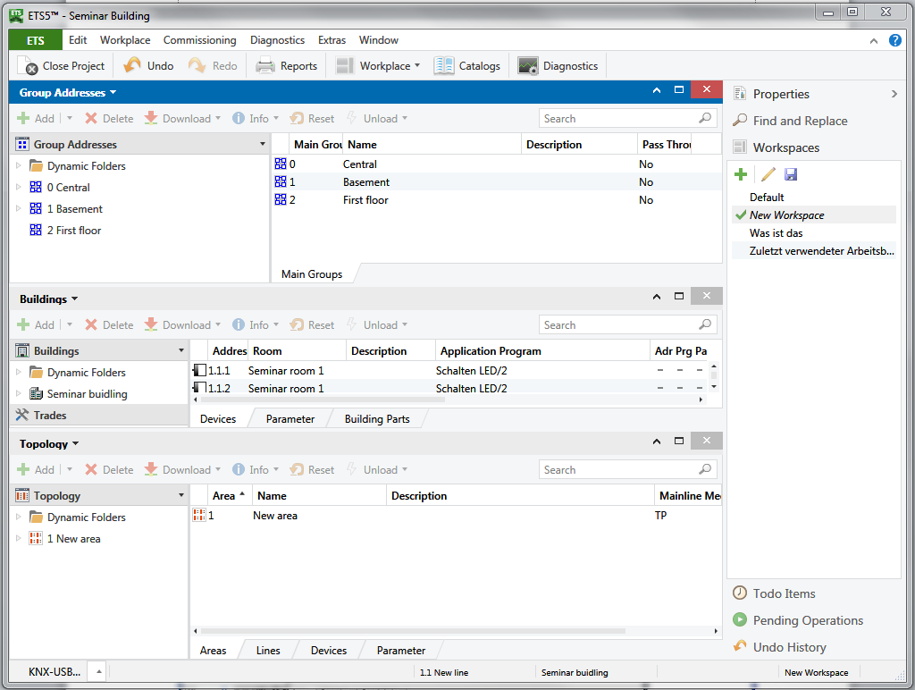
Figure 1: Example of a workspace
ETS enables you to create so-called workspaces. One is already “supplied” and is available when installing the software (called “Default” or “Standard”). The default workspace cannot be deleted, but it can nevertheless be modified. A workspace is a project-independent, user interface template. You can achieve the following with the help of workspaces: each project designer will only see the information on his screen that he needs for his work. All unnecessary data is not displayed. The various views (e.g. building structure, topology, group addresses) as well as their structure and lists are arranged according to your personal needs.
The same project can look completely different when using different workspaces. A project designer needs different information compared to someone who is merely doing commissioning. The concept of workspaces takes these differences into account.

Which properties of the screen elements are stored in a workspace?
- All open windows e.g. Topology, Group Addresses, Building View, Diagnostics
- The position and size of these windows
- The internal columns and structure of areas
- The visible columns and their layout (sequence)

Note: The workspace does not memorise any opened areas!

How can you now create your own workspaces?
This is extremely simple: As soon as one thinks to have found the desired placement of screen elements (number / type / size / layout of the windows, number of columns, order, content), you open in the tool area (normally located on the right side) the rubric “workspace” (1). There you click on the “plus” symbol (2) in the header and then assign a useful name (3) to this workspace.
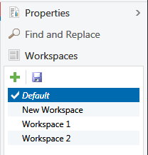
1
2
3
Figure 2: Saving a workspace
Adjusting the presentation of the window:
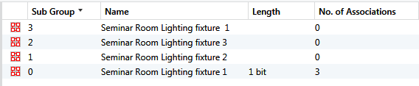
Figure 3: Adjusting the window

Click with your right mouse button on a column heading in the window which you want to adjust. A pop-up menu will appear, in which you select the columns you want to see.

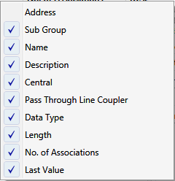
Figure 4: Adjusting the columns

Other editable properties that are not saved in workspaces:

- Toolbars:
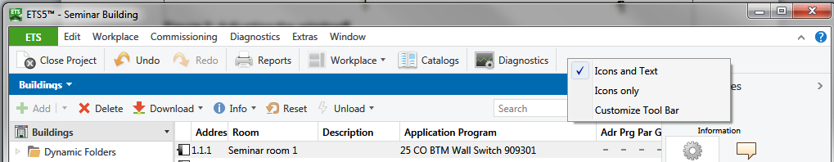
Figure 5: Customizing toolbars (1)

Click on the toolbar with the right mouse button. It is possible to choose to display “Icons and Text” or “Icons only”. By clicking on “Customize Main Toolbar”, all required icons can be dragged onto the toolbar (or removed again).

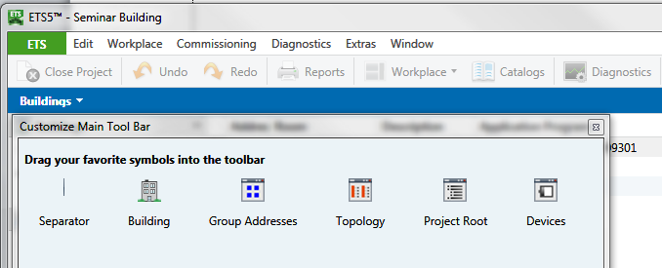
Figure 6: Customizing toolbars (2)

- Interfaces: The currently used bus interface for download as well as for diagnostics is shown in each window, where you have the possibility to access bus devices. For download and diagnostics two different interfaces can be used. When saving workspaces these interfaces will not be saved, as they may change from case to case (different protocols like USB or IP or even simply different interface couplers). Difference is made between „discovered“, „configured“ and „current“ interfaces.

  - „discovered“ means: currently available. Each of the discovered interfaces will normally also work.
  - „configured“ means: manually configured IP - interface, which is not accessible because the network address cannot be accessed.
  - „current“ means: Always the currently selected interface for bus access.

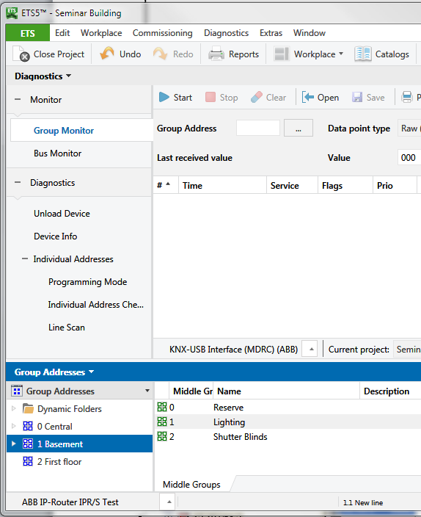
Figure 7: Bus interfaces – for diagnostics and download different interfaces can be used at the same time

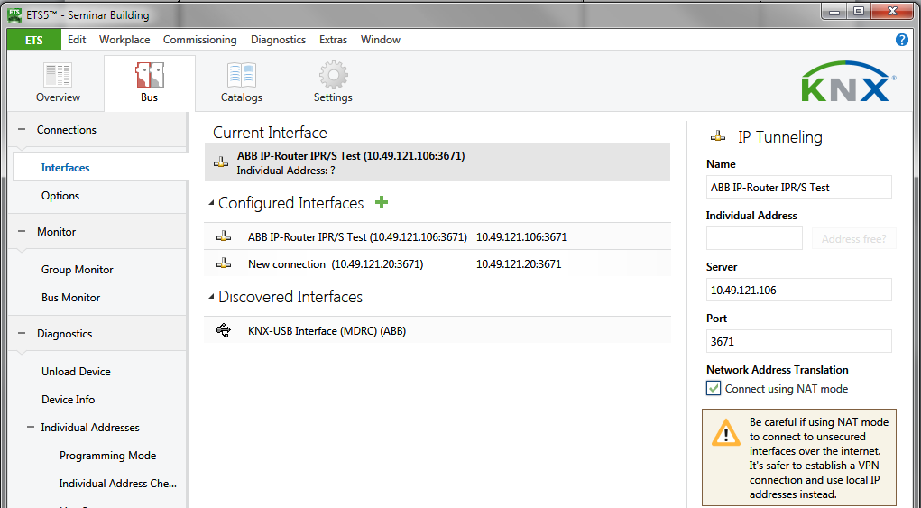
Figure 8: List of interfaces

Shortcut keys
Practiced users of a software package can carry out working steps quicker when using the keyboard instead of the mouse. If you e.g. wish to use the functions of the main menu, they can all be accessed via the keystroke combination “Alt” + < underlined letter> of the menu item name (context-sensitive shortcut keys). There is also a whole collection of absolute shortcut keys, which can also be displayed and modified via Settings / Shortcuts.

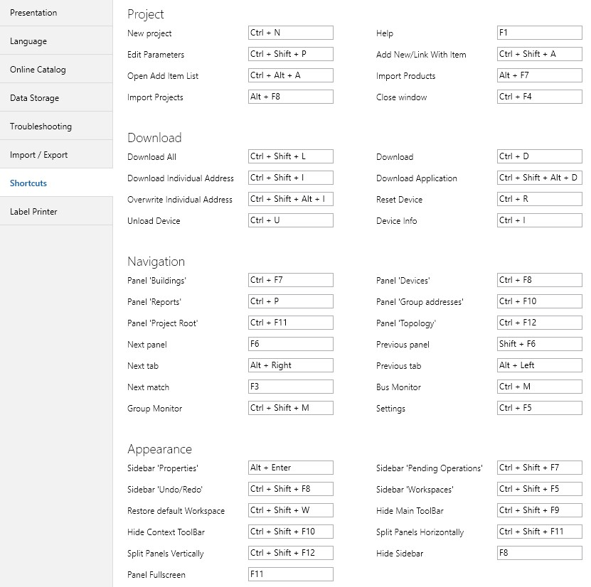

Figure 9: Shortcut keys (extract)

Example: You wish to link a new group address with a displayed object.
The keystrokes are as follows:

You select the intended object – in the following picture „Button A1, Switching“

By entering: “CTRL“ + “SHIFT” + “A” you access to the dialog for entering the new address. There are three things that should be taken into account here:
- If a new address had not been created before, the tab „Existing“ will open and an already existing address can either be entered or selected from the context.
- If in the current session a new address shall be created for the first time, in addition „CTRL“ + „TAB“ has to be pressed.
- For each further new address, step two will be cancelled, as ETS keeps in mind, what has been done previously.
Note for the entries: ETS accepts all possible notations, independent from the selected group address structure. This means that “307” will be automatically changed to 0/1/51. Space characters are also accepted as separators.

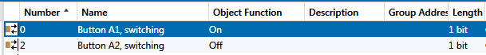
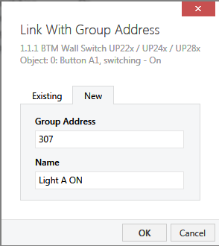
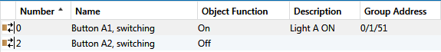

Figure 10: Creating a manual address link via the keyboard

Advanced topology
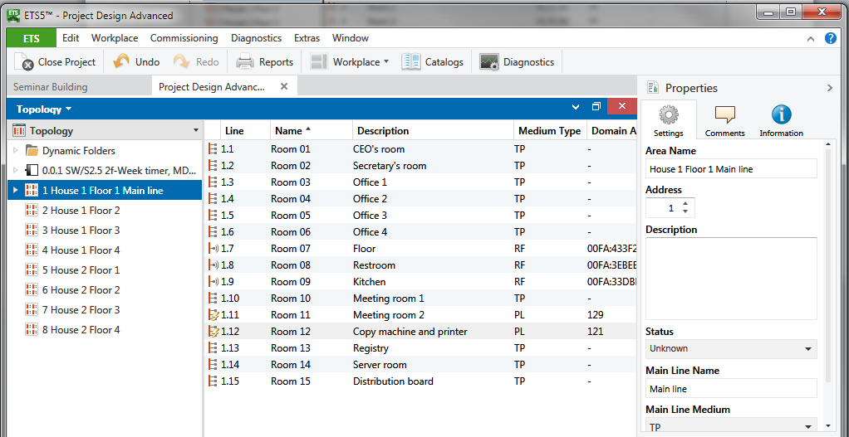
Figure 11: Max. expanded topology with examples for assigned texts

Structuring and planning reserves
In the diagram above, you can see how to create many areas and lines in a project: 15 areas, and in each area 16 lines. You can see by the name how the topology could be aligned to the building structure. This of course depends on the size and structure of the relevant project. There is no single model solution for this! It is advisable to design a larger project completely without topology and to establish the assignment in the topology after completion of the project design. What is the best way to proceed?
- Observe a reserve of approximately 20 % per line segment (i.e. for maximum 64 bus devices, this amounts to approximately 50 bus devices).
- Central devices should be installed in main lines or in backbone lines.
- Devices of connecting room groups should also be put in the same line segment (under no circumstances several segments in a room should be mixed, unless the upper limit of 64 (or 50 with reserve) has been exceeded. In that case, this should be clearly documented!
- On the same floor (or in the same house) you should if possible only install one area (do not fill up when 1 or 2 lines are free).
- In case of smaller projects in many cases one line per floor is sufficient.

Support from ETS when setting up larger size topologies:

Creating several areas

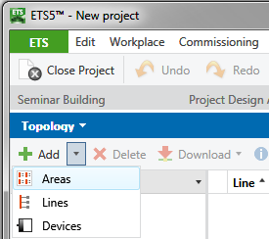

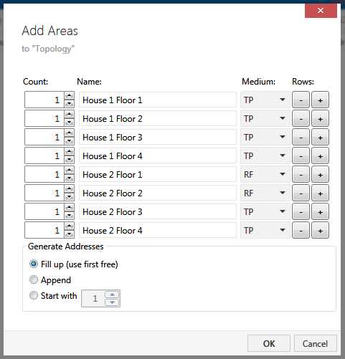
Figure 12: Creating several areas
In the window „Topology“ simply click with the right mouse button on the symbol „+ Add” → Areas and enter the areas successively in the dialog. If desired, the strategy of generating the addresses must be customized; the settings are adopted by pressing OK and the areas are created.

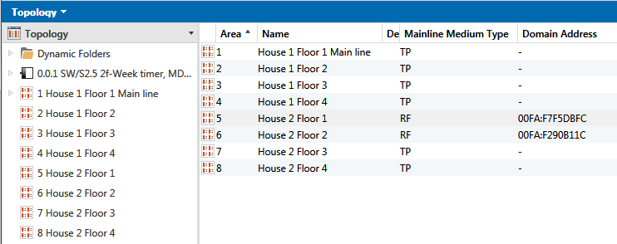
Figure 13: Creating several areas (2): the backbone appears on the left side

Creating several lines
The same procedure can also be applied to lines. In this case, click with your right mouse button on the relevant area, and proceed as in the paragraph above!

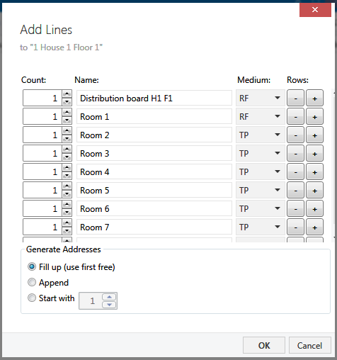
Figure 14: Creating several lines

Notes: If the same line structure is required in all the areas, it is advisable instead of first creating all the areas and then all the lines per area to create and label an area completely including its lines and then to duplicate it using copy and paste.

In ETS5 there are no more separate main lines and area lines (as in ETS4). Of course they do exist (that is now a criterion for plausibility). The devices of these lines appear either in the structure tree, if the area is “opened” or on the right side in the list view, if the area has been selected previously. In figure 11 you also can see, that there is nevertheless a separate name for the main line.

Find and replace - Strategy
Text alterations can be carried out very conveniently using “Find and Replace”: First mark a line in the list that is to be modified, then activate the “Find and Replace” function. Enter the search text and replacement and then click on the appropriate button underneath.

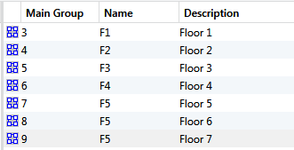

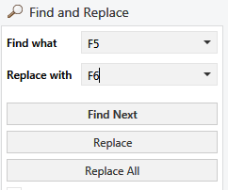
Attention !
Figure 15: Find & Replace

This process should however be used with care; e.g. text can also be modified inadvertently by pressing the “Replace All” button. It is better to first locate the text that needs to be modified with “Find” and then to correct one after the other with “Replace”.

Different media (Powerline, RF, IP)

General:
Today ETS directly supports 4 media: Twisted Pair (TP), Radio Frequency (RF), Powerline (PL) and IP. This can also be distinguished in the topology. As soon as different media will be used in one system, the media specific rules concerning the usage of the couplers have to be taken into account. In order to link different media, you need the appropriate media coupler. The plausibility of the settings is controlled by ETS to a large extent. If e.g. lines for Powerline are created, then the overlying connection (main line) line must be of the type TP. PL and RF are so-called “open media”, of which the telegrams can mutually interfere. To avoid this interference, so-called domain addresses are used. This is supplementary information added to the addressing sent with each telegram.
In this case telegrams containing the same data can clearly be distinguished when there are two neighbouring domains.
Then again, the media setting does not necessarily have something to do with the coupler that is being used: Even if an IP router is used as a line coupler, the secondary line must be set as a TP line! The media that is supported by a device or on which it can be operated can easily be seen in the Catalogs view in the column “Medium Type”.
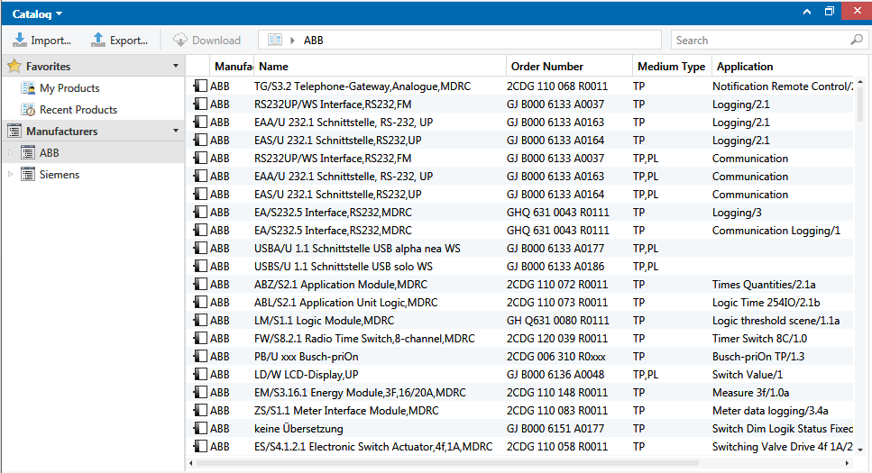
Figure 16: Media of devices: some support several media

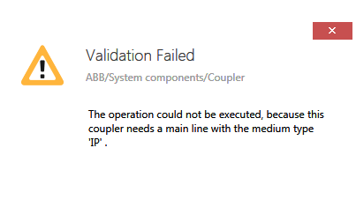
Figure 17: Error message when inserting an IP Router: Main line = TP
In the column medium the respective transmission medium can be selected; in case of Powerline the necessary domain address will be created automatically by a random generator. If necessary, it can be edited later on.
All non-TP lines are also marked by corresponding symbols, so that they can immediately be distinguished from the standard TP lines.
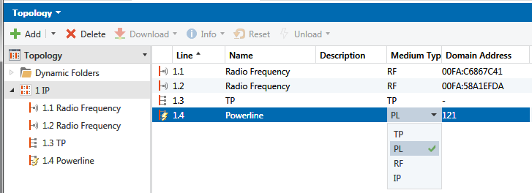
Figure 18: Topology with different media: (nearly) everything is possible

Plausibility rules:
In the „Help“ of ETS it is explicitly explained, whereon attention has to be paid when using other media besides TP. Here a short summary of it:

Powerline (PL)
- Requires domain addresses of 1 Byte, will be displayed in decimal format
- Main lines – if of the type PL – pass their domain address to the lines.

IP
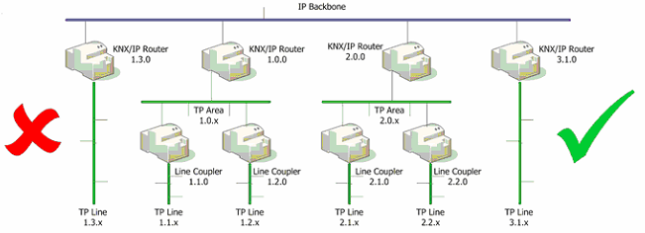
Figure 19: Topology combination of IP and TP: allowed - forbidden

- As soon as an IP Router is required, the backbone line has to be of the type „IP“.
- All IP Routers are always directly connected to the backbone line.
- IP-Line Router (e.g. address 3.1.10) and IP–Area Router (e.g. address 2.0.0) can exist side by side, but never in the same area!
- Below an IP–Area Router only „non IP“-couplers are allowed.
- Multicast: As all IP Router within one project have to communicate with each other, they have to share the same multicast-IP-address (e.g. 224.0.23.12). This is ensured by ETS via the properties of the backbone line and will be transferred automatically to all IP Routers of the project. Older versions of IP Routers therefore still have own parameter settings. These will be overwritten by ETS during the download!

Radio frequency (RF)
- Requires a 12-digit (6 bytes) hexadecimal domain address with the following notation:
HHHH:HHHHHHHH. Leading and trailing zeros have to be entered!
- Backbone: RF – backbone line is not allowed
- In a RF – Domain only one (media-) coupler is allowed
- RF domains may have different sublines (all of the type „RF“), of which the domain address has to be the same and also the main line has to be of the type „RF“. This is ensured by ETS.
- If a main line is not of the type „RF“, all secondary RF lines have to get own domain addresses and RF-couplers. This is also ensured by ETS.

Interlinked building structures
The Building View is indispensable for the project designer of a larger project, because of the documentation purposes alone. Only in the Building View, can it be completely understood where each component is installed. You have to maintain the following structure in ETS: buildings – building part (floor) – rooms/cabinet. However, there is an exception to the rule: room/cabinet can also be located directly under a building. Devices can be inserted in four locations, in a room / distribution cabinet, in the view “Devices”, in the view “Project root” or in the “Topology” view. . All the devices that are not created via the building structure (in the topology and trades) are inserted first. They should be linked in the correct place in the Building View at the latest when the project is completed.
A problem regularly occurs if a building has not been built according to the “standard” e.g. in other words it does not have clearly recognizable floors. In this case, the interlinking of the building parts will help you further. This structural element can be freely subdivided; moreover rooms/cabinets can also be inserted directly in buildings. This may be necessary when you need to design a project for a sports centre for instance. The rooms are inserted in the building and there are no floors.

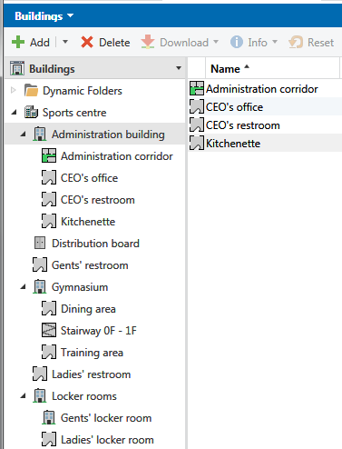
Figure 20: Example of an interlinked Building View

Inserting devices, systematic descriptions
The devices are inserted after setting the structure of the building (see Project Design, Part 1). Four fields can be used to describe each device: Name, Description, Comments and Installation Notes.
The differences lie in the field size and the presentation in the columns or in the download dialog.
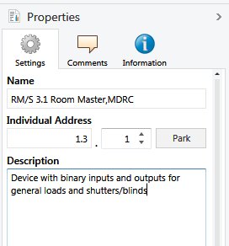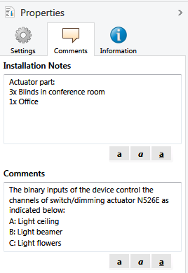

Figure 21: Text description fields for devices
The description field has only 80 characters, the name can however be 255 characters long, whereas comments and installation hints can have an unlimited length. Moreover they can be formatted (bold, italic, underline, and colour). The name and the description are also displayed in the display columns of the device views such as line view, room view or all devices (unless they have been “hidden” via the workspace setting). They are also displayed when downloading.
The installation notes and the comments can however only be viewed in the Properties dialog or printed out in the documentation. They are generally used (as the name already indicates) to make detailed comments about the commissioning or installation. However, in the case of devices with a large number of channels, it is often necessary use these for commenting as the name and description fields cannot take all channel designations due to their size limits.
Finally, there is also an editing status below the description field, which you should use to document the current editing state of the respective device. Via a dynamic folder with the criterion “Completion status” “is not” “accepted”, you can view at any time all the devices that have not yet been accepted by the customer.
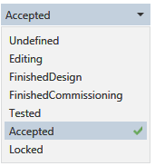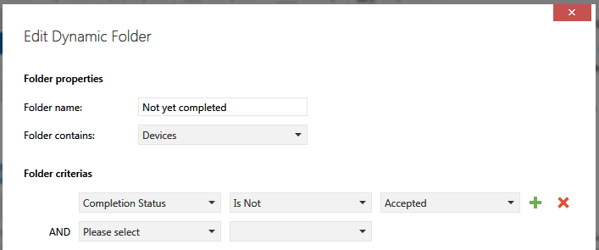
Figure 22: Editing- (completion) status

Examples of device descriptions:
You should use a systematic legend when creating the description. It should contain the following data in an abbreviated format:
- Place of installation, e.g. DB1
- Device type, number + number of channels (e.g. SDA 1f = 1-fold switch/dim actuator, ShA 4f= 4-fold shutter actuator, SwitchA 8f= 8-fold switch actuator, PB 2f= 2-fold push-button
- Channel number + its function, e.g. Ch1_on/off
- Functioning location of channel, e.g. R12
Example:
SubDB_H1F3_ SwitchA_4f(1)_R12_Ch1_L05,
Ch2_L06,Ch3_L07,Ch4_L08_on/off
Means: Lights 5-8 in room 12, 3rd floor of the first house, switching, executed at switch actuator no. 1, which is installed in the distribution board on the 3rd floor.

Group addresses Advanced

Structure of the addresses
ETS offers 3 options for structuring addresses:
- 2-level (historically from ETS1, practically not used anymore)
- 3-level (used in ETS2 and ETS3, also suitable for larger projects, fixed folder sizes and quantities on 3 hierarchical levels)
- Free address structure: The user can set up his own interlinked structures within the entire 16 bit address range.

3-level address structure
The author recommends on the basis of years of experience the following structure for a single building with max. 31 floors:
- MaGrp. 0 Central functions
- MiGrp. 0/0 – 0/7: Function-dependent subdivisions of the central functions
- MaGrp. 1 – 31: Floor no.
- MiGrp: 0-7 Functions per floor
- SGrp: 0-255: Room features per function and floor
As the available address range within one project cannot be extended to any size, you have to look already at an early stage for alternative solutions if at least one of the upper limits is exceeded. These alternatives could be: Fragmentation into several projects (e.g. in case of more than 31 floors) or usage of the free group address structure (if the total amount of required group addresses will remain <65536).

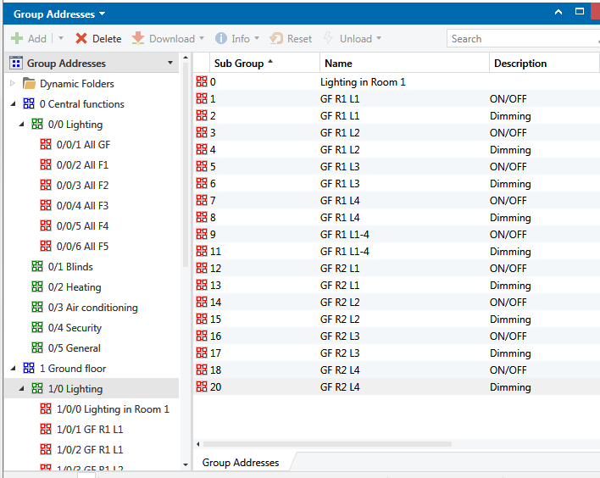
Figure 23: Example of group address structure and designation

Free address structure
The possibility to structure group addresses completely free is offered with the introduction of the fourth generation of ETS. ETS5 also supports this feature. The randomly created structures with 2 or 3 levels in the early periods of the KNX/EIB-system bear certain restrictions because the addressable range for the group addresses is always limited to fixed address ranges. If someone creates e.g. the middle group „Central“ and only needs there 10 addresses, then the remaining 246 addresses (which maybe would be urgently required for the middle group „lighting“ cannot be used anymore).

Now it is possible to create one’s own free group address structure. The free group address structure is also not limited with regard to the number of levels. In this way the planning engineer can use all group addresses without any gaps.
Nevertheless, some attention has to be paid to some matters:
The export and import can only be done in the XML-format, i.e. you require an XML-editor instead of a normal spreadsheet calculation.
Already when creating the project you have to make your decision for such a structure. As soon as another structure is required, it is not possible anymore to change over from a 2/3 level format into the free structure (and vice versa). Further attention has to be paid to the fact, that the OPC-export is not made any more via the menu item “OPC Export), but from the group addresses window via “Export groups” -> XML (ETS4 format) or CSV, ETS3 incompatible. Finally many manufacturer plug-ins still have problems with the free structure, as the make the address assignments in the parameter dialog and there only the 2- resp. 3-level format is provided.

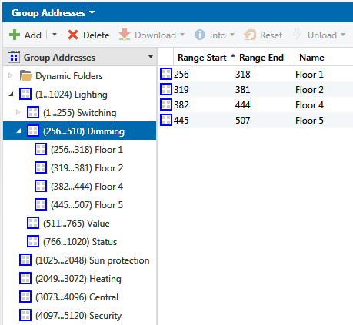
Figure 24: Presentation of freely structured group addresses

Description format
A group address describes a function. It is therefore also directed at the operational equipment and not at the bus devices concerned performing this function (sensors – actuators). For instance, you want to dim light 5 on the 1st floor in the 2nd room. It is not appropriate to give a group address such a long description. That is why you should establish a scheme before starting a project. It should contain abbreviations with all the necessary information about
- location where the function takes effect, e.g. Building-floor-room
- controlled equipment or equipment group, e.g. Light 1, Shutters 1-4, Heating for whole floor
- Type of function (e.g. dimming, switching, set value, shutter movement)(see also the comments in the device lists).

For all trades/devices and function unique identifiers have to exist, which also have to be included as attachments to the ETS-project.
Example: A block of 3 buildings, 4 floors per building, and up to 20 rooms per floor:
- H1F3R12_L05_on/off = means: Lights 5 in room 12, 3rd floor, building 1, switching.
- H3F2R08_L01-04_dim = means: Lights 01 – 04 in room 8, 2nd floor, building 3, dim continuously.
- H2F3R07_Shu01-03_stop = means: Shutters 1-3 in room 7, 3rd floor in building 2, stop
- H2F0R03-06_Shu_mov = means: Move all shutters (up/down) in rooms 03 – 06, ground floor, building 1
- H1-3_Light_central_on/off = means: Central switching of all the lighting in buildings 1, 2 and 3.
- H1F1R14_Heat_SetPt= means: Heating information – desired setpoint temperature in room 14, 1st floor, building 1.

Explanation of the abbreviations: H in the first location = House; F in the second = Floor;
R in the third = Room; 4. Identifier: L = Lighting, switched; LD = Lighting, dimmed, RO = Shutters; H = Heating

The examples mentioned above illustrate how you can establish self-explanatory descriptions with only few characters. It makes sense that the name for the location and equipment group should be re-used for the actuator (see Inserting / Copying devices). This makes the assignment much easier afterwards.

A good recommendation, which is in the same line, is e.g. given by KNX Swiss in the following technical guideline:
http://www.knx.de/knx-chde/wdownload-d/Projekt-Tool/KNX-Swiss-Technische-Richtlinien.pdf

Group address settings
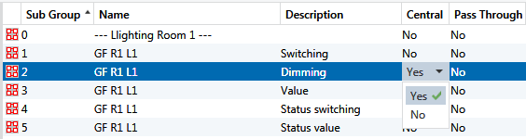

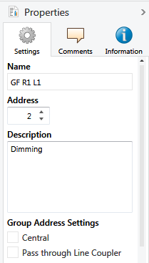
Figure 25: Address settings
When designing a project, different options allow you to determine how group addresses are to be handled.
- Pass through Line Coupler: When a group address is set to ‘pass through’, it is entered in the filter tables of all line couplers. It is therefore not filtered when telegrams containing this group address do not actually belong in the line they are sent to. You can choose this option to enable e.g. central functions that are used in almost every line. In this case, it will not be necessary to re-program line couplers, when the installation is extended in the future.

- Central: This property only has significance inside the ETS. Group addresses that are set as such will be taken over unchanged in newly created devices when you “Copy with options”. This will of course save you considerable copying work since only the local group addresses will have to be newly assigned; the central functions will be kept.
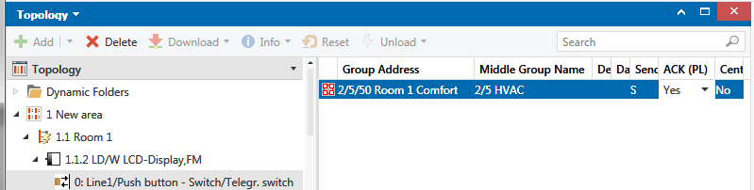
Figure 26: Setting the group speaker: ACK (PL) = Yes
- Group speaker: Only relevant for Powerline. In Powerline systems, only one device must be available for each group address to send an acknowledgement (Acknowledge) when receiving a group telegram with this address. A group speaker property must be assigned to a Powerline device, i.e. in the object which is linked to the corresponding group address. Please note: Just as the sending address in the case of a “Transmit” flag is an object property assigned to this specific group address, the same applies to the group speaker flag: you first select the device (in Topology view or in another view), expand the objects in the tree structure and select the object with the corresponding group address, so that it appears in the right window pane. The option “Yes” can then be set in the ACK (PL) column (see figure above).

Creating large numbers of group addresses

General
There are – as always – several strategies to get to the final result. No strategy can be called „the best“ for all cases, as its advantages and disadvantages are dependent on the project. Also the number of available possibilities plays a major role here.

With the on-board tools of ETS (without APPs) already large numbers of group addresses can be created, and – important to mention it – with correct or nearly correct marking.
If a spreadsheet calculation (as it is usual today) is available, it also can be used to generate address tables, and this often faster and with more options with regard to the text processing / Find & Replace.
In principle this is also possible with the project design wizard of ETS, yet it is very limited. It delivers clear, but also uncommon segmentations, for which there are no setting options.
Finally there is also the option to not generate the group addresses in a separate step and to connect them later on with the communication objects of the bus devices, but to copy and insert them together with whole bus device structures. In the default version of ETS only one target structure (main/middle group) can be selected, i.e. only structures with less than 256 addresses can be copied without losses. One further big disadvantage is that it is not common to copy group addresses from one single middle group and therefore the targeted middle group has to be re-worked again.

Creating directly in ETS via the planning wizard
Already before having started the project design you have to decide, if you use the “normal” procedure or you use the help of the wizard. The selection cannot be changed afterwards. The resulting structure is diametrically opposed to that what you normally will learn in a training course. Due to the fact that the main groups define the trades, many group addresses get lost. Furthermore the wizard creates large gaps, if within the rooms only a few devices have to be controlled. Therefore this strategy is only suited for smaller projects.
On the other hand there is a big advantage: None of the standard addresses are lost, typing errors are absolutely avoided.

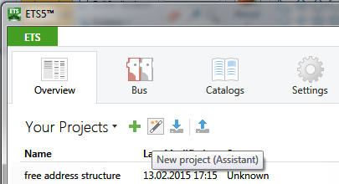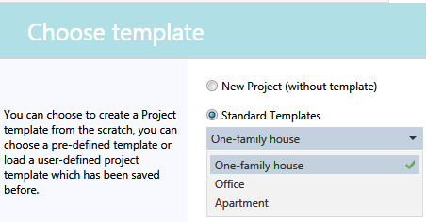
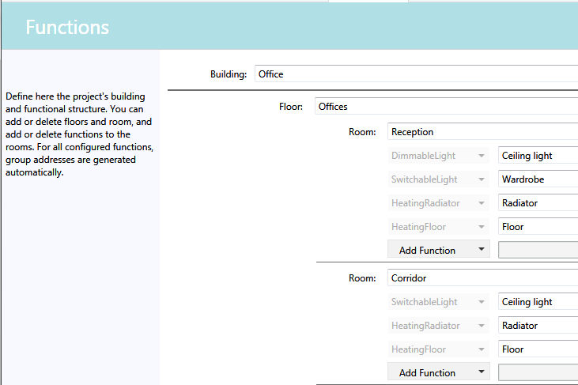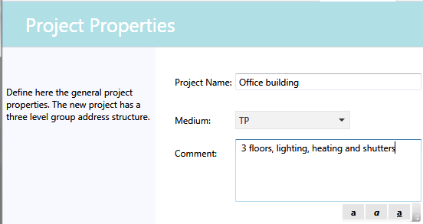
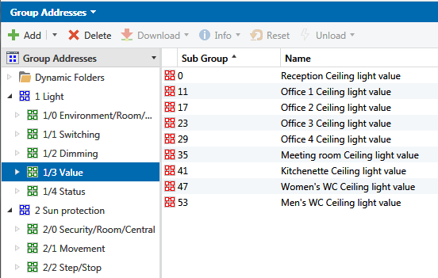

Figure 27: Creating group addresses via the planning wizard

Creating directly within ETS in the group window
As in the topology, the “Object generator” can also be used for the address structuring. You can use 2 strategies:
- Complete each main/middle/subgroup individually with addresses.
- Copy an existing structure from a main group into another.

Example for strategy 1: Creation of new floor-related main groups
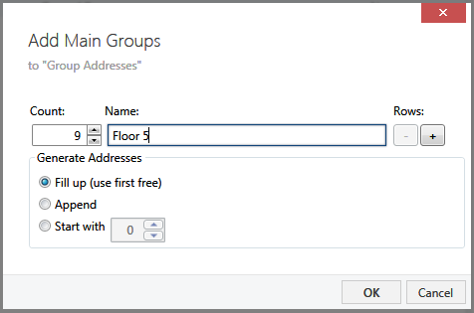
Figure 28: Creating main groups 1

Result:
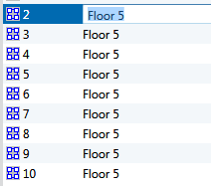
Figure 29: Creating main groups 2
The text must still be edited e.g. the floor numbers must be inserted. This can be done however without subsequent editing if you use the row expansion option (and then only 1 instance per row):

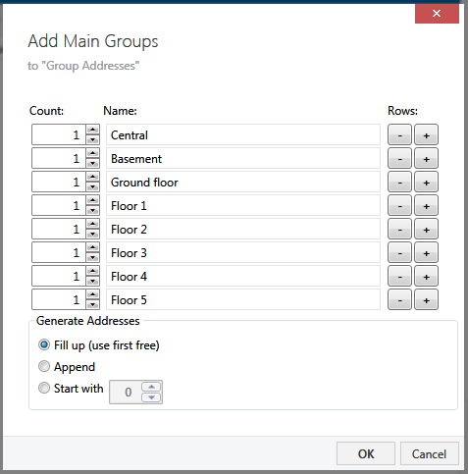
Figure 30: Creating group addresses 3

Example of strategy 2:
Copying an existing structure:
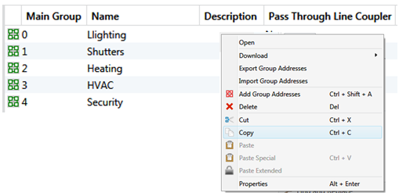
Figure 31: Copying of (middle) – group addresses (1)
Then click in the desired main group and press “Ctrl + V”:

Result:
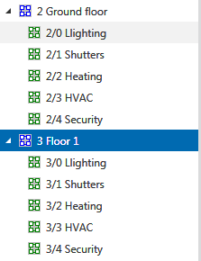
Figure 33: Copying of (middle) – group addresses (2)

Creating by export / import to / from a spreadsheet calculation:
Group addresses can be directly exported from the Group Addresses window and then re-imported. Professionals can use this to generate the address lists conveniently outside ETS e.g. in a spreadsheet program such as EXCEL. This section briefly describes the process: To obtain a suitable CSV file for further processing as a template, one should first generate a small starting structure in ETS. This is then exported as a CSV file in 3/3 format with a header line. In EXCEL, it is important that separators are clearly recognised, TAB being the most suitable, so that EXCEL also creates the 8 columns required for a 3-level group address structure. If the opening of the CSV-file does not show the correct result – as shown below – the imported text columns can be modified later on. EXCEL 2010 offers therefore e.g. the text conversion assistant. The required addresses can now be generated in EXCEL. The sequence is of no importance. One should however avoid ambiguities or address numbers outside the defined range. With regard to the CSV-format the free group address structure is not supported. The reason for is, that this structure can be chosen completely freely. Further attention has to be paid, that the current format (XML as well as CSV) includes data point type information. Further it is planned, to abandon the OPC-export format, which has become obsolete in the meantime (see also chapter 12).

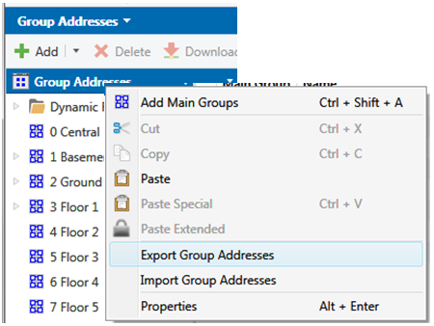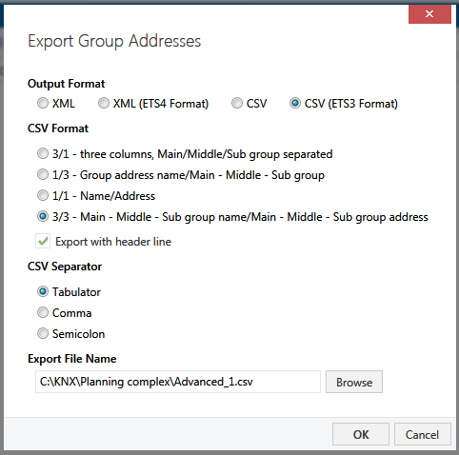
Figure 32: Exporting a CSV- file with group addresses to EXCEL – format settings

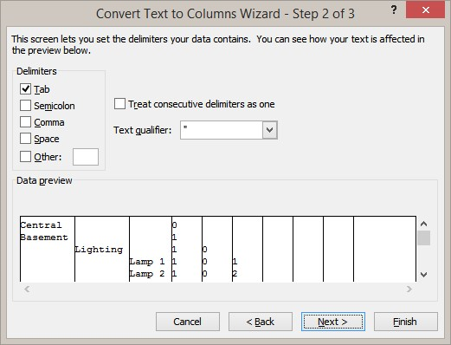
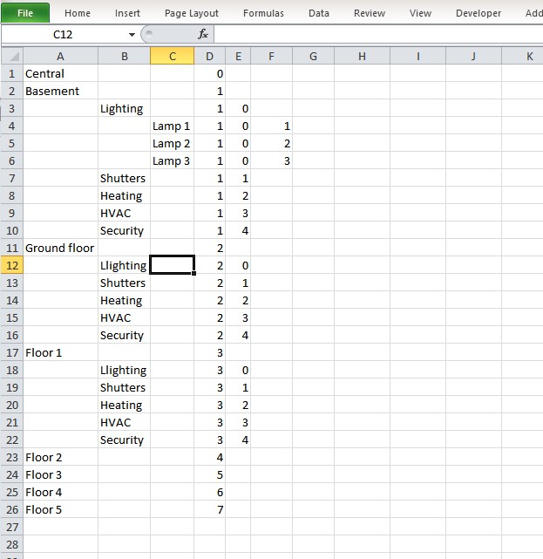
Figure 33: Importing a CSV- file with group addresses to EXCEL – format settings
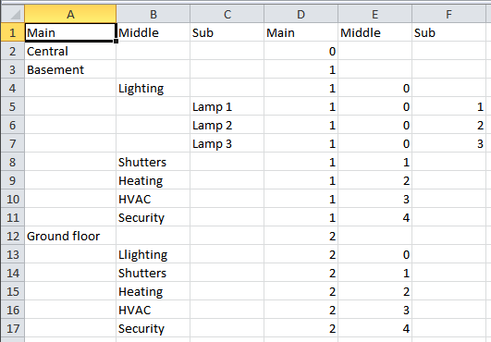
Figure 34: View of the CSV file in EXCEL

Professional functions, tools (APPs)
Since the year 2012 KNX Association runs a sort of „APP Store“ in its internet portal. With the introduction of ETS5 the portal has been renamed into MyKNX (https://my.knx.org). In the meantime a wide range of auxiliary tools - which make working with ETS even more efficient - is available. The tools are offered either directly from the KNX Association or from registered KNX manufacturers. The APPs of the KNX Association are already contained in ETS, they only have to be activated by the APP-license. APPs of other manufacturers basically have a setup (with the file extension ETSAPP) and have to be installed separately.
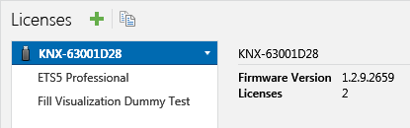
Figure 35: Licence list, options
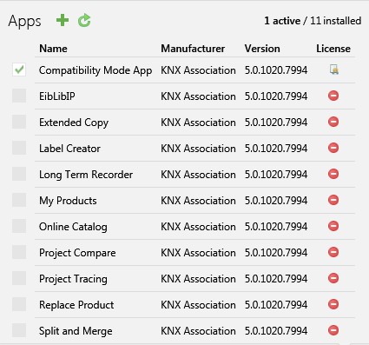
Figure 36: License list, Options

Copying with options (ETS „on-board tools“)
You can basically copy all elements in a project, i.e. group addresses, buildings, building parts, rooms, lines etc. You can do this either with drag & drop (hold down the Ctrl key) or just as in Windows using the Ctrl+C, Ctrl+V key (or via the menu).

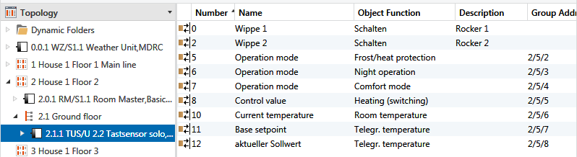
Figure 37: Example: Copying devices (1) – initial position
Initial situation: The already completed heating controller part of the combined push button/heating controller 2.1.1 shall be copied 5 times.
Such select it, push simply “CRTL+C” (or with the right mouse button in the context dialog “Copy”).

Important: The newly generated group addresses will all get identical names, i.e. no addition like “copy of”. Such it makes sense, to use an identical text element, like e.g. the room name, which is assigned here to the columns “description”. In the screenshot shown below 5 further rooms are “prepared” as far as it concerns the group addresses. As ETS will create 7 new group addresses per device, these will be inserted accurately fitting into the gaps between the headlines.

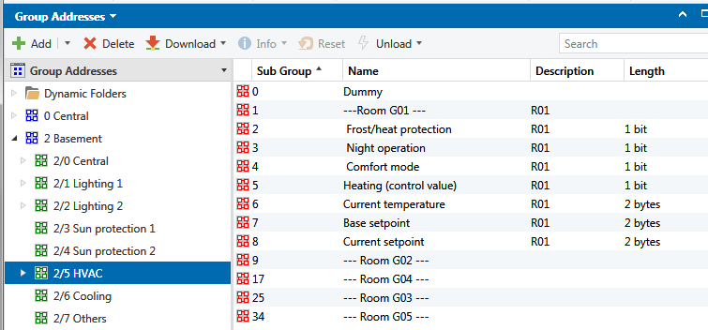

Figure 38: Example: Copying of devices (2): initial addresses

Now you select the e.g. the targeted line (here again 2.1) and press “CTRL + V”. The following dialog will be opened:

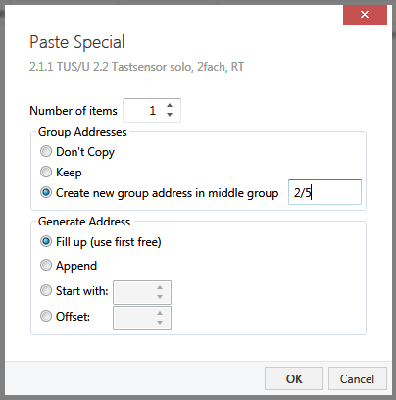
Figure 39: Settings dialog for copy with options

If you copy devices, you have two options.
The selected devices can be copied with all additions and properties (e.g. group addresses, changed parameters etc.). Such you save time, as the new devices are automatically copied, their parameters and address connections will be taken 1:1 from the original device. Concerning the group addresses three strategies exist: create new group addresses, keep them or don’t copy them.
- Case: Keep. This option is suited, to copy identical devices (e.g. push buttons within a corridor or staircase) completely and identically. No new group addresses are created, only a new individual address. The parameter settings are taken over from the source object.
- Create new: Here you have an option which saves the manual creation and connection of new group addresses. This option has to be prepared very carefully. Reason: each new address link will be newly created, but if the counterpart has not copied together with it, ETS does not know this and will generate new further addresses – which do not fit to the previous step - if the forgotten device will be copied later on. Therefore: in case of copying with creation of new addresses all involved devices have to be copied “in one go”. Exceptions are “Central addresses”: They will not be changed when copying. This property can be used deliberately, in order not to “clone” such addresses which don’t have a counterpart. Of course real central functions will not be created as newly generated copies. Moreover this option has two further restrictions: it is limited to a targeted middle group and therefore to maximal 256 group addresses (see chapter 7.4.1).

- Do not create new address connections: If only the device is needed, you want to copy it with the already set parameters and don’t want to take it with the standard parameters from the catalog, then this option has to be chosen.
The result of the copy operations is too comprehensive in order to describe it here. What still has to be done now: The new devices and addresses have to be adapted in their description. As for all elements we had chosen the room designations, it is very simple now, to create the corrected texts by “Find and Replace” (as already previously shown).

Extended copying - APP
(Currently not available yet for ETS5)

Undo – function
When you are working on a project, you often face the issue of restoring an intermediate state, when wishing to do certain things in a different way.

The function called “Undo / Redo” can be used for this purpose. It allows reversing a number of steps or restoring them under certain conditions.

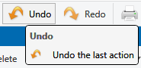

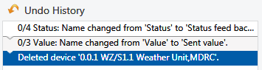
Figure 40: Undo / Redo in the toolbar / list of reversible actions

For this, ETS saves all the actions of the project engineer. The maximum number of actions that are saved can be set via “Settings” – “Presentation General” between 0 and 200. If this number is reached and there are further entries, the oldest entry is always overwritten. Since all the previous actions are also displayed in a list, you are able to reverse a series of actions in one go, especially if they are directly linked to each other (example: Find & Replace stepwise). This function however also consumes performance resources. When you for instance use the complex “Copy with options” function described before for entire building structures, you have to basically calculate about twice the time for this action compared to when not using this option. The option can therefore also be switched off (with the value 0).
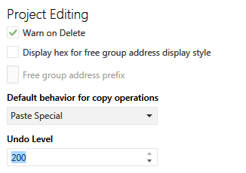
Figure 41: Setting the Undo Level (in „Settings - Presentation“)
Please also note: This function is a local function. The stored work steps can only be undone as long as a project in the actual ETS-session is opened. As soon as it is closed, all modifications will be consolidated.

Which options are now available?

On the one hand, it is possible to click on the two buttons in the main menu bar. You can however also open the “Undo History” in the “Side Bar” to see what has been saved there. An entire sequence of steps can in this way be reversed or restored in one go - if appropriate. Actions that are greyed out have already been reversed once but can still be restored.

Dynamic folders
In so-called „dynamic folders“, contents can be stored according to specific filter conditions e.g.:
- Bus devices that still need to be programmed
- Lines without bus devices
- Group addresses without object associations
- Download lists (if you are editing certain devices across all the structures and wish to program them collectively, they are stored in the dynamic folder called “Modified devices”).
- All bus devices of a specific manufacturer
- All bus devices which have a switch function
- All group addresses (especially interesting in relation to the status display “last value” in the group address window!)
- …. and much more.
Dynamic folders are global filter definitions, which are not connected with a project. Their impact is identical on every project in the local memory.

The benefit of dynamic folders is that they are always “up-to-date”.

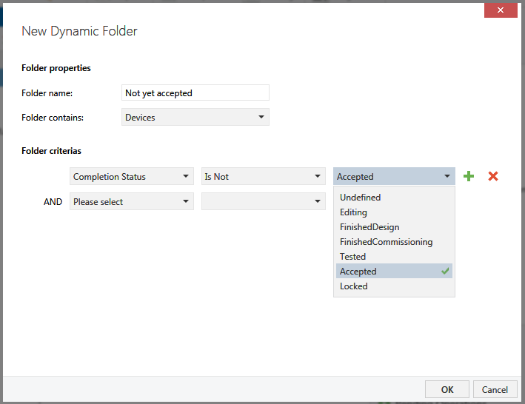
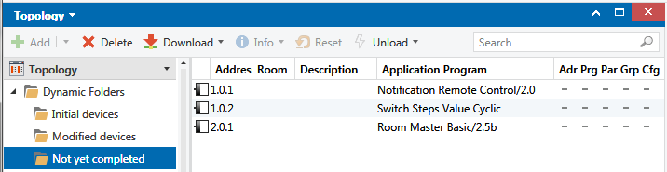
Figure 42: Example of a dynamic folder: all devices whose status is not yet “accepted”

Checking and editing filter tables, permitted group address ranges
Line / backbone / or media couplers must be inserted for logical coupling, as soon as two or more bus lines are created in a project. In order to avoid that group telegrams of one line are sent unnecessarily on another line, each line coupler must be loaded with a filter table. The filter table consists of a bit matrix in the permanent memory of the line / backbone coupler. Each bit represents exactly one group address. If the coupler receives a group telegram, it will check in the filter table if the bit has been set for this group address. If so, it will redirect the telegram to another line. If not, it will do nothing.
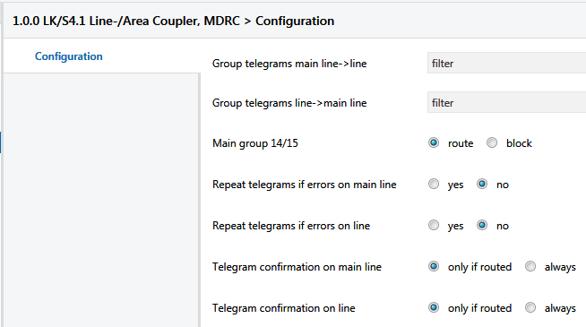
Figure 43: Coupler - parameters
Since ETS4 the whole possible group address range can be used, i.e. also the main groups starting from 16 up to 31. The range of the filter tables of older versions of line couplers will not be extended automatically. On one hand the address range is limited by the hardware (memory space for the filter table, formerly only 3.5 kB) and on the other hand it is limited by the application. Figure 44 shows e.g. an older version of a line coupler, which only supports main groups 0..13. Further up all telegrams will be handled in the same way – as shown for the main groups 14/15. Up to now only a few manufacturers have adopted their line coupler applications to the new features. Most probably the situation will change in the near future.

For the planning of the address range it is also very important, to know the properties of the planned line couplers or routers, resp. to acquire the information about with respect to the planning.

For test purposes, parameters can be set in such a way that couplers will route or block all group telegrams, whereby both transmission directions Line → main line or vice versa can be set separately. You will find sufficient details about setting the parameters and the function of the coupler in the chapters “Topology” or “Bus devices”.
You will find a detailed explanation in the project design example below as to why filter tables should be activated in normal mode.

Automatic filter table
The project designer does not have to deal with the correct creation of filter tables provided that the project contains all information regarding in- and outputs (=senders and receivers). In this case, ETS automatically generates the correct table. The creation of the table starts with the download of the coupler. That is why filter tables are not displayed, but are loaded straight away in the coupler.

Manually created addresses in the filter table:
Nevertheless, there are cases, in which the tables cannot be generated correctly because of the fact that devices receive or send telegrams, whose parameters cannot be set in ETS, for instance gateways or visualisation programs. Also for this case, a solution is needed to correctly set the filter tables, just for these addresses, but not yet completely.

There are two options available:

  - Manual configuration of the filter table
  - Use of a dummy application

To a): In topology, in addition to the devices created in the line, you can also insert the group addresses which are to be linked manually.

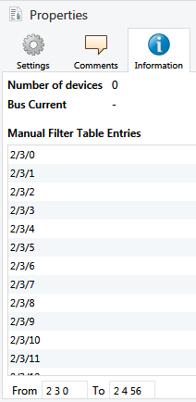
You can do so simply by dragging the group addresses from the Group Address view into the Topology view. If you drop them onto a line, the Properties entry “Manual filter table entries” appears.

Alternatively, you can also use the input field “From” and “To” below this list.

This procedure is not appropriate for a larger number of lines, as one personally has to keep track of where group addresses need to be inserted manually.
Figure 44: Manual filter table entries

b) Is for sure the better method:

Using a dummy application
A dummy application is set as a virtual placeholder for the real visualisation. In the Topology view, it does indeed look like a bus device but is not really installed. It merely represents a sort of “calculation aid” for ETS for the setting of filter tables. Let us suppose a visualisation needs to be used in main line 1.0. You then insert a dummy application in this line and link all group addresses used in the visualisation with this application. The great advantage of this application is that it again ensures that all the filter tables in a project are calculated automatically.
A dummy application normally has a very large address capacity and variable object types, so that it is possible to assign any number of addresses.
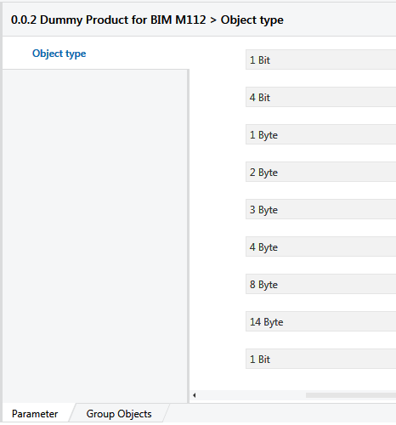

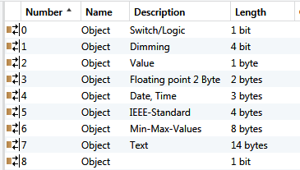
Figure 45: Parameters / objects of the dummy application
Ideally, this dummy application can have the interface address of the visualisation and an appropriate comment can be entered as device description:

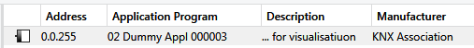
Figure 46: Dummy product for visualisation
In order to connect the group addresses with the dummy application first of all the required object types (data length) have to be created after which the group addresses have to be dragged & dropped with great effort on to the correct group object.

ETS-APP: Fill-up a visualisation dummy
In the KNX APP-Store an APP „Fill-up visualisation dummy“ is especially available for the comfortable use of such a dummy application. This APP automatically detects the data lengths of the objects, which are connected to the group addresses to be activated. In this way it is possible to connect the group addresses with the group objects in a fast and uncomplicated way.
The APP accepts moreover any KNX product, of which in the Name or Comment fields the word “Dummy” is present.

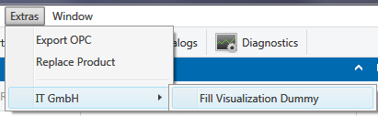
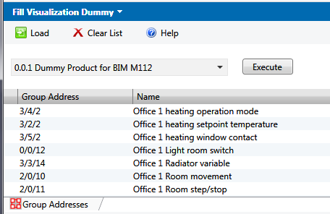
Figure 47: Fill-up visualisation dummy

Checking the project
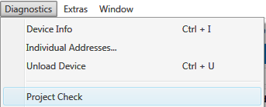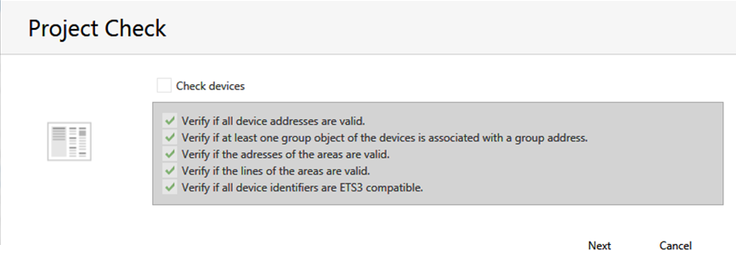

Figure 48: Structured project check
After termination of the engineering work on project, before the first commissioning work starts, even before ordering the material, it makes sense to check the whole project structure if all requirements really have been met.

ETS can support here to a limited extent, by means of the integrated, structured checking algorithm.

The following properties are checked:

- missing or wrong / wrong number of system devices such as power supplies, chokes, line and area couplers. ETS will show an error for lines that have attributed bus devices but do not have any system devices. Lines without attributed devices are not evaluated → Device check
- missing group address assignments (group addresses → device and vice versa). Here it is expected, that a group address is at least assigned to 2 group objects, and that one bus device has at least 1 object link to a group address → Group address check
- missing individual addresses (inserted devices not yet assigned to a line) → Topology check
- Product information check

The steps in detail:

Device check
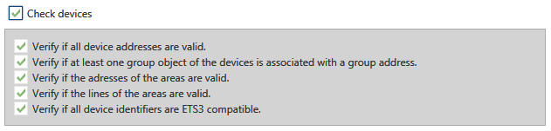
Figure 49: Device check options

Group address check
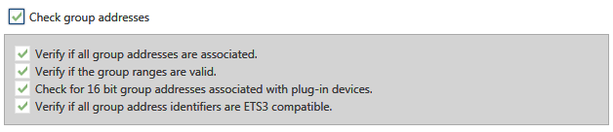
Figure 50: Group address check options

Topology check
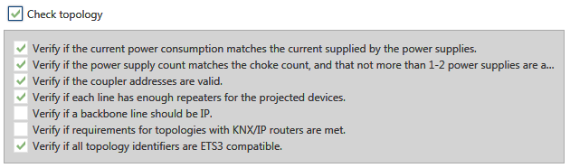
Figure 51: Topology check options

Product information check
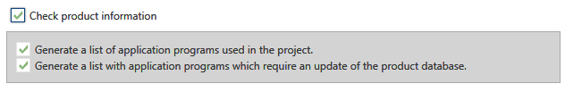
Figure 52: Product information check

The test results illustrate very clearly what is missing or has been forgotten and by clicking on the hyperlinks in the results screen, you can jump to the objects with errors.
The product information check is particularly interesting if a manufacturer has several applications per device. The check then shows which update options should be used if possible.

Limits of the ETS project check
ETS can really only detect very rough errors. It is obvious, that such an automated check cannot find logic errors of the project engineer. If e.g. the group addresses have been assigned incorrectly or uncompleted or a device has been assigned to the wrong line, this cannot be detected.
For example, it is also not possible to guarantee that parts lists are complete as accessories such as connectors, data rail, bus terminals and above all bus couplers (for all flush-mounted devices requiring them) can indeed be inserted from the catalog but are not compulsory.

On the other hand, detected but uncorrected errors will not prevent configured bus devices from being downloaded, as long as they have an individual address and the line is powered by a suitable power supply unit.

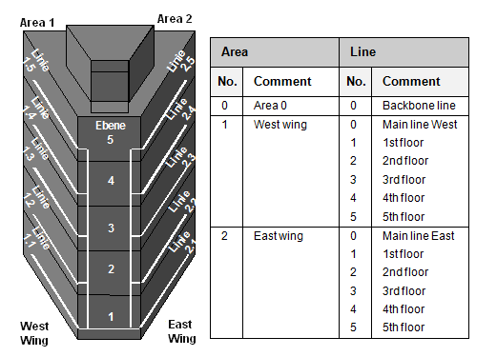
Figure 53: Division of lines in a medium sized project

Bus hierarchy

General considerations
Before you finally start the actual ETS project design work, you should have made a rough draft for the later assignment of the bus devices. Assignment means: area and line addressing. Moreover, it is about translating project requirements put forward by the client into the functional scope of the available bus devices. For instance, a requirement could be: “Emergency function for lighting and blinds must be guaranteed in the event of a bus failure”. In this case, the corresponding actuators must be selected under these prerequisites. Devices without manual operation are hence excluded right from the beginning. We will deal with this issue later.
If higher data throughput is to be expected, one should contemplate to create TP lines as islands, connected to an Ethernet network via TP/IP routers, which has a significantly higher transmission rate.

Taking into account the building structure
In order to maintain a clear overview, also during later extensions and servicing work, the division of the KNX system into lines and areas should be optimally adapted to the real building structure. The easiest way would be that a building could represent an area and the floors could represent the lines.
If however the number of bus devices that are placed in these individual segments deviates significantly from the requirements regarding cost efficiency, you need to modify the structure accordingly, resulting in the most cost-effective but nevertheless convenient solution.

Including customer requirements
Client demands can moreover considerably affect the bus structure which has to be installed later on. These may include:
- Actuators should all be principally installed in distribution boards, accessible from the outside in order to reduce interruptions in the event of service and maintenance work.
- To make cabling easier and therefore have fewer load circuits, actuators should always be installed as close to the load as possible.
- In larger buildings with standard room types, all bus devices of a room should be installed together in the same environment (e.g. room control box).
- Instead of perhaps 4-fold or multiple push-buttons, only single or 2-fold push-buttons should be installed, as these are easier to operate and to label.
- The operation costs for bus lines (i.e. supply of energy, uninterruptible power supply and so on) should be reduced if possible, while accepting the disadvantages in terms of safety.

Consideration of system limits, planning of reserves
In order to be prepared for any possible changes in the course of the planning phase and also for the future expansion of the system, you should include reserves in your calculations. In plain language, this means – taking into account the general conditions given above – that a bus segment should be equipped with at least 30 bus devices in the first stage with a maximum of 50. Bus lines can each be supplied with a single or even 2 power supply units or 2 segments can share a power supply unit with 2 chokes. In special cases, even devices with a distributed supply can be used (see chapter ‘Topology’). Please also ensure that the available energy is sufficient for further expansions! It is not always possible to install the upper limit of 64 bus devices, when the current consumption of the devices exceeds the capacity of the power supply unit. On the other hand, a stronger power supply unit (e.g. 1280 mA) cannot guarantee that you can operate 64 devices, as the total impedance of the line is reduced due to the higher total current consumption, thus negatively influencing the signal form and transmission range. Until now, the manufacturers have refrained from providing detailed information on this topic since it is impossible to describe all exceptions and find a reliable functioning solution for each possible case. You are therefore expressly reminded here again, that the limits mentioned in other chapters (64 devices but no more than 1280 mA no-load current) must always be respected.

Line coupler or IP router ?
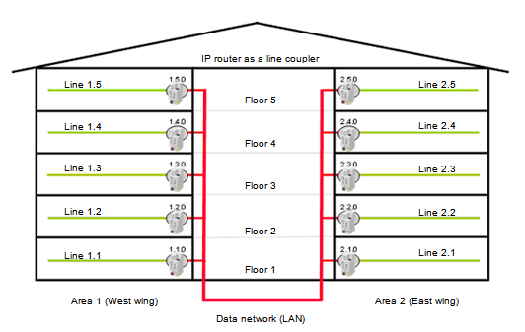
Figure 54: IP Routers replace line couplers

For many years now, more and more IP routers are installed next to the classic TP-TP line couplers. Nowadays, they are still significantly more expensive but offer several benefits that should not be underestimated:

- In addition to the standard multicast routing function, each IP router offers one or more so-called IP tunnelling links.
- These tunnelling links can be used for ETS remote access as well as for access by visualisation programs.
- If it is planned to have a fix installed data interface per line, the use of IP routers will always be favourable.
- If you access the associated line directly with ETS via an IP tunnelling connection, you always have the fastest possible communication link available
- The visualisation can also be made considerably quicker if it can be linked to all IP routers simultaneously via a single data interface.
- In the vertical communication KNX to Visualisation, speeds of up to factor 225 can be achieved (225 lines in parallel equals 225 x 9.6 Kbit/s = 2.16 Mbit/s)

In principle one can say that the more lines that are needed and the more data points that are centrally monitored, the more worthwhile the use of IP routers becomes

Data rates and cyclical processes
The data rate, which can occur on average or in critical cases, should also be calculated right from the beginning. Time-critical functions requiring a quick reaction (real-time applications) should if possible not be planned and designed across lines. In this case valuable tenths of seconds could be lost when passing through line/backbone couplers. This applies to dimming, especially cyclical dimming. If such local functions are realized across several couplers, this will affect the linearity of the variation of light intensity. Moreover, the start and end delay of the function may in some cases be too high

You should also pay attention to the total data rate for all devices with cyclical sending. Cyclical transmitters are all alarm sensors (e.g. wind and rain detectors, weather control units, smoke detectors, window contacts), which should be continuously monitored to ensure that they are functioning correctly.

The security level of the bus system does not always increase when setting such a device to “sending” as often as possible, but more by choosing a rate that is adapted to the potential bus load.

Even more critical are devices and software packages that cyclically poll the status of their communication partner. The fact is that this will result in at least two bus telegrams per data point –the polling telegram as well as the corresponding answer.

In addition, normal bus load can be endlessly “increased” by incorrectly configured line and backbone couplers. The following section will outline an example, taking into account the aspects mentioned above. It shall however be noted that with this example is only able to touch upon a small proportion of all possibilities of a flexible and variable system as KNX!

Further below (11.3), you can find a calculation example for planning or calculating bus telegram loads.

Planning a project: Example
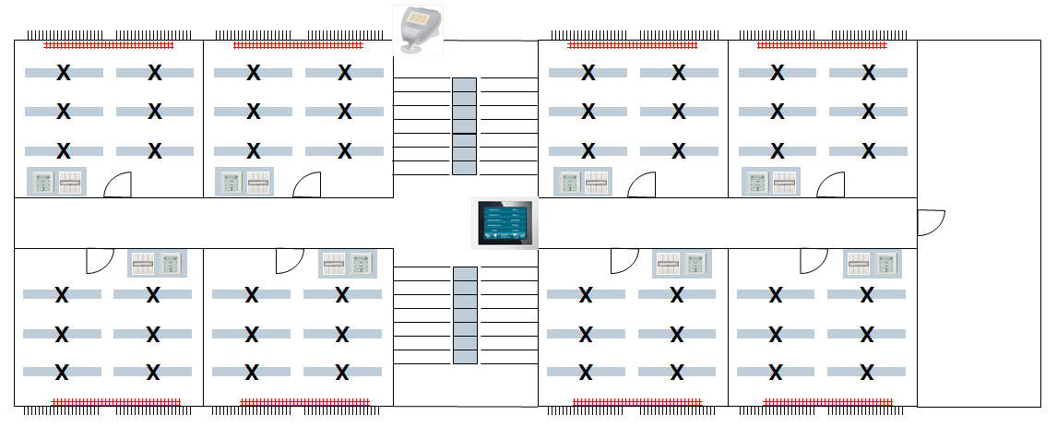
Figure 55: Office floor with 8 rooms

Requirements / regulations (specification text)
A bus line contains the equipment of a floor with 8 rooms. The functional requirements for each individual room are:
- 3 dimmable lighting circuits; 4 x 58 W; can be manually switched both separately as well as together, changeover switch to automatic operation
- 2 shutters, proportionally adjustable, can be manually controlled both separately as well as together
- 1 radiator, with proportional control and the corresponding heating controller
- 2 window contacts, which lower the temperature when the windows are opened
- 1 room information and control panel, displaying the functions and values of the temperature controller (setpoint and current temperature, night/day operation mode), indicating storms and displaying the state of the shutters and lighting control (manual/automatic) and also allowing to control the latter
- for the operation 2-fold or 4-fold push-buttons, also realizing a central function: basic lighting (2 of 3 strips of lights) on; all lights off + shutters up.

Moreover, a weather control unit is used, which amongst other things has the following functions for the rooms:
- Wind sensor: raising shutters in the event of a storm
- Light sensor: when a pre-determined brightness limit is exceeded, closing of shutters, switching on lighting control and proportional control of slats, raising the shutters at nightfall
In addition, a central time switch is used, which
- controls the room temperature profile centrally on a weekly basis
- switches off lights at night when still turned on
An information panel is used per floor, which displays for each room
- whether a window is opened
- current temperature values and setpoint
- if still somewhere lights are switched on
- position of shutters (has limit of 30% been exceeded?)

On a summary page for each floor, the following should be displayed
- at least 1 window open – yes/no?
- at least 1 light on – yes/no?
- at least 1 shutter lowered (more than 30%)?
In order to generate group signals, appropriate logic modules must be used. The automatic slat function depending on external brightness is implemented stepwise (3 steps) by means of an analogue threshold value converter.
All status signals – including the group signals – should run centrally in a building visualisation.

Task definition
Now, you have to assess, if
- one bus line segment is sufficient or if two are needed
- which bus telegram load can be expected?
The underneath explanations show that this assessment can lead to substantial differences, which can influence the success and failure of the KNX technology.
You can now use ETS first in order to select possible bus devices:
From the great quantity of available devices, the following could have been selected:

Parts list for solution 1:
Per room:

3 switch/dimming actuators (1-channel)
1 brightness controller
1 valve drive
1 contact interface with 2 inputs
1 heating controller
1 display with at least 6 display functions
1 x 2-channel shutter actuator
4 x 2-fold push-buttons
1 logic module for the light/shutter group signals
1 logic module for the connection of the window contacts
___________________________________________________________________
15 devices
x 8 = 120 devices

In addition:

1 logic module for the conversion of analogue threshold values into binary signals (shutter)
3 logic modules for - all windows, - all shutters, - all lights

1 information panel
1 time switch
1 weather control unit
____________________________________________________________________
makes exactly 127 devices

When taking into account the reserves, 2 lines and a main line are therefore necessary

Another possibility is to proceed as follows:

Parts list for solution 2:
Per room:
1 x 3-fold switch/dimming actuator with integrated brightness controller
0.25 x 8-fold shutter actuator (used for 4 rooms)
1 valve drive with 2 integrated contact inputs
1 Room controller with integrated heating controller and 8 display functions
1 x 4-fold push-button
______________________________________________________________________
Total per room 4,25 devices x 8 = 34!
In addition:
1 logic module for the conversion of analogue threshold values into binary signals (shutter)
1 logic module for all binary connections for the group signals
1 weather control unit (as above)
1 information panel (as above)
1 time master (because the timer functions can also be realised by the analogue threshold value generator, when it receives the time signals on a regular basis).
_______________________________________________________________________
This totals only 39 bus devices! Only 1 line remains, instead of 3 as in the first case!

Conclusion: Through an accurate survey to determine which optimum device configuration is possible, you can save up to 50% of the costs!

(Morover by using DALI for lighting purposes all switch-/dimming actuators can be replaced ; → instead of 8x switch- / dimming actuator only 1x DALI GW = 32 devices.)
Presuming that solution 2 is implemented, we now proceed to the second part of the study:

Determining the bus loads

Scenario 1:
According to the parameterisation of the components, the specified functions can lead to a noticeable telegram load on the planned bus line.

Status signals that are sent automatically in a 3-row lighting circuit with a sampling rate of one 1 second also generate between 3 and 6 telegrams (!) per second. That makes 3x the 8-bit brightness value + (when switching on/off) the 1-bit switching state. We know that there can never be more than approximately 48 telegrams per second and with maximum cable length only 24 telegrams per second (the latter is however not the case here). However, we have 8 lighting circuits. If you multiply this with the numbers above, this already results in 48 in the worst case. However, many other bus devices also send out telegrams simultaneously on a regular basis! The scenario could look like this in the worst case:

- Each room display unit polls the status 1x per minute (6x) = 12 tel./min.
- The logic module (56 inputs) is also set to cyclical polling of all inputs, with an interval of 30 seconds per polling cycle = 224 tel./min.
- The analogue threshold value converter polls 16 (shutter) states 1x per minute (= 32 tel./min.)
- The building visualisation polls the state 1x per second (= 120 tel./min.)
- The wind sensor sends 1x per minute (= 1 tel./min.)
- The brightness sensor sends 1x per minute (= 1 tel./min.)
- The floor information display polls up to 10 states every 10 seconds (= 120 tel./min.)

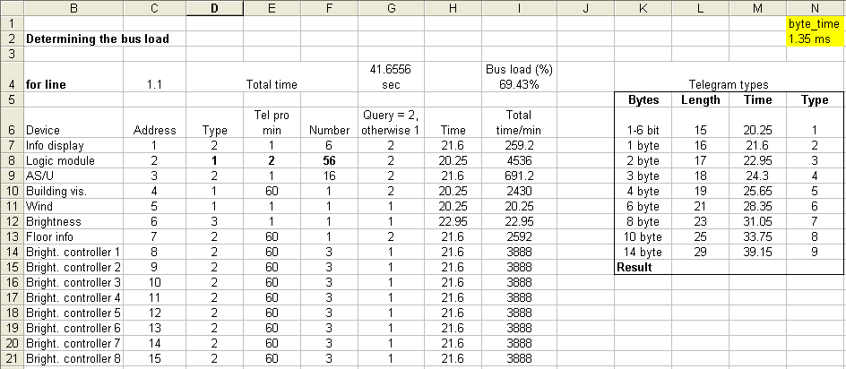
Figure 56: Spreadsheet in EXCEL for determining the bus load / transmission time per minute

These were by far not all of the telegrams sent on this bus line, only those that were created by the automatic control loops and those devices returning statuses. Nevertheless, the 7 points listed above result in a total of 502 tel./minute or 8 –9 tel./sec., which represents a bus load of approximately 20%! Together with the lighting control without modification of the switch status, this already amounts to 70 %!

Always set the line/backbone coupler to “filter”!
The following however adds to the problem: (unfortunately quite frequently) the filter tables of the line/backbone coupler are made “inactive”, by setting the standard parameters from “filter” or “normal” to “route everything”. This can lead to a serious problem. This leads to the following estimate:

The system above exists exactly twice. Both lines are connected via the main line, in which the weather station and the visualisation are located. The couplers are “unlocked”, i.e. they let all group telegrams through unfiltered.
Now the following happens: all telegrams listed above are also channelled in the neighbouring line and vice versa. However, in this line there is no receiver. Consequence: The coupler repeats these telegrams after the initial transmission another 3 times. If bus loads above 100% were possible - we already reached 100% without lighting control – this would theoretically result in 350% bus load with lighting control. This is of course limited to 100% and as a consequence frequent losses of telegrams and delays when transmitting.

ETS supports quick calculation as well as optimized short download of filter tables: they are constantly updated in the background; only bytes that differ from “00” are taken into account when downloading the coupler. This process is made possible by a fast-erase algorithm, which first sets the old filter table to “zero” before the new one is loaded

Now it still needs to be verified whether the cyclical polling intervals need to be as short as mentioned above or whether cyclical polling is necessary at all. Let us look at an alternative:

Scenario 2:
Underneath another solution that offers almost the same security, but a substantially lower bus load: (we assume that all changes to the corresponding bus devices are sent automatically and that they basically do not need to be polled at all)
- The 8 lighting controllers now only poll every 5 seconds = max. 576 tel./min. (or 288 without change in the switching state)
- The room information displays poll 1x every 5 min. (= 2.4 tel./min.)
- The logic module now only polls every 5 min. as an additional security measure (=22.4 tel./min.)
- The analogue threshold value converter also polls every 5 min. as an additional security measure (=6.4 tel./min.)
- The visualisation does not poll at all, as all important information is already either sent event driven by the bus devices themselves in the line or is additionally polled (= 0 tel./min.)
- The floor information display now only polls 1x per minute (= 20 tel./min.) per function
__________________________________________________________________
Result now: 627 tel./min. or 339 tel./min. or approx. 11 (22%) or 6 (12%) tel./sec.
The difference is remarkable! What is more, not one function is unacceptably delayed, and all signals are generated immediately as before! It is still possible to reduce this rate even further, how can be determined by the reader himself, in accordance with the here outlined specifications.

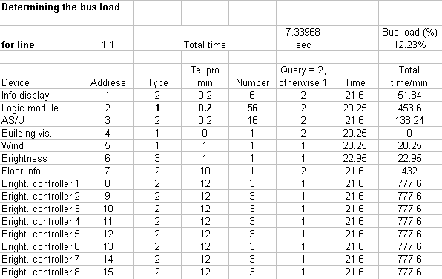
Figure 57: Spreadsheet in EXCEL for determining the bus load / Scenario 2

Summary of the bus load calculation
If we should draw a conclusion here again:
The optimum function of the KNX network depends directly on the most accurate estimation of the data rate in the most unfavourable and average condition. You should always take into account, that the bus system is first and foremost event-driven and cyclical repetitions of unchanged states are only necessary as back-up functions with a relatively long time interval.
Lines or backbone couplers shall be set to “normal” mode, when normal operation is adopted, i.e. the filter tables must be loaded, and the evaluation algorithm for the filtered transmission must be activated.

Administration functions, project documentation and archiving

Reports
In order to document a project, a series of reports are at your disposal.
There are different perspectives to create documentation:
- Building structure with allocated devices
- Parts list (important for orders!)
- Bus topology overview
- Detailed lines and device lists
- Group addresses
- Commissioning status

A detailed printout of the Building View with all available information would already be sufficient in theory. However, it would be very difficult to quickly find out from this report - purely arranged according to the building structure - information for instance about the equipment of a bus line, about the whole topology structure and about the number and structure of the group addresses used. The information as to which devices was downloaded and with which result can also not be deduced from that.
The device details, i.e. configuration of flags, object flags, comments and assigned addresses, should not be printed out in the Building View but in a detailed line printout.

How to proceed?

It shall be first noted that ETS reports always produce a global view of the project. Print outs of certain parts of the installation are only possible via partial printouts or by exporting to a file format other than ETS (see below).
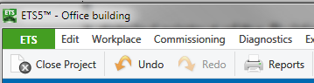

Figure 58: Starting the documentation tool
Clicking on the printer – icon „Reports“ in the toolbar you get access to the printing and report generation window.
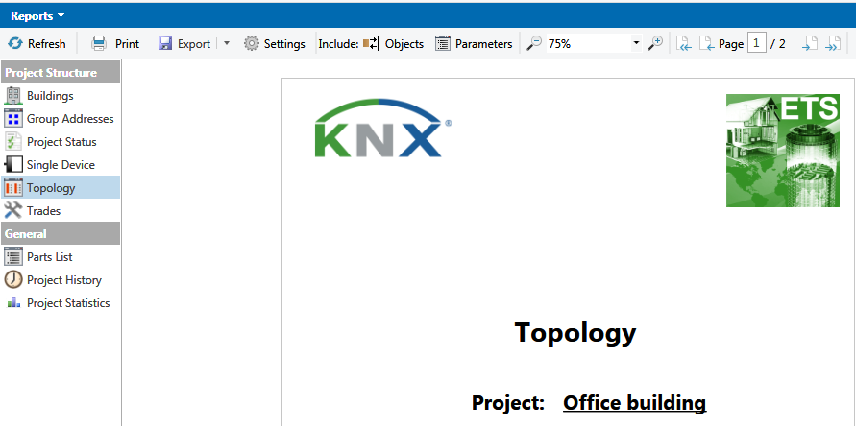
Figure 59: Report dialog
The procedure is clear: you select a report (left side) and press the button „Refresh“. As a result a preview is generated, which can be exported either as a PDF-file or can be printed out. The level of details can be increased by selecting „Objects“ and „Parameters“.
Examples:
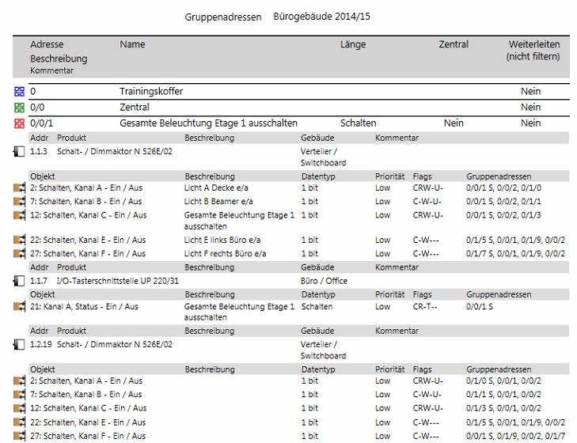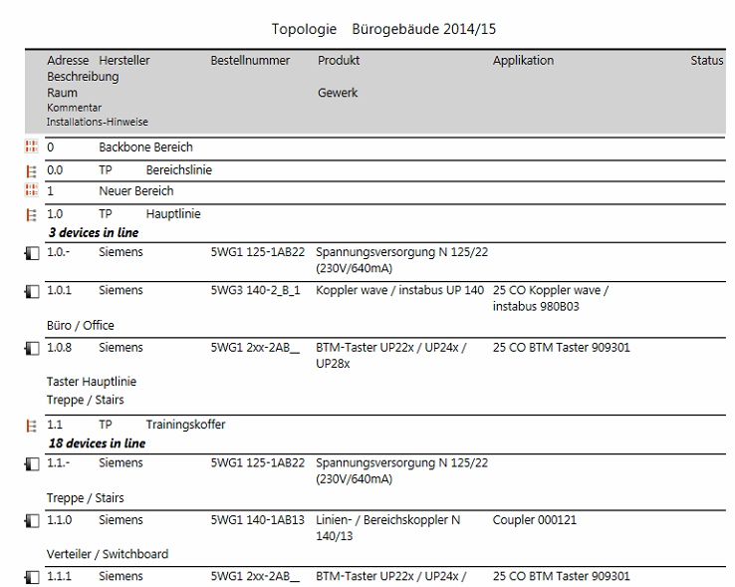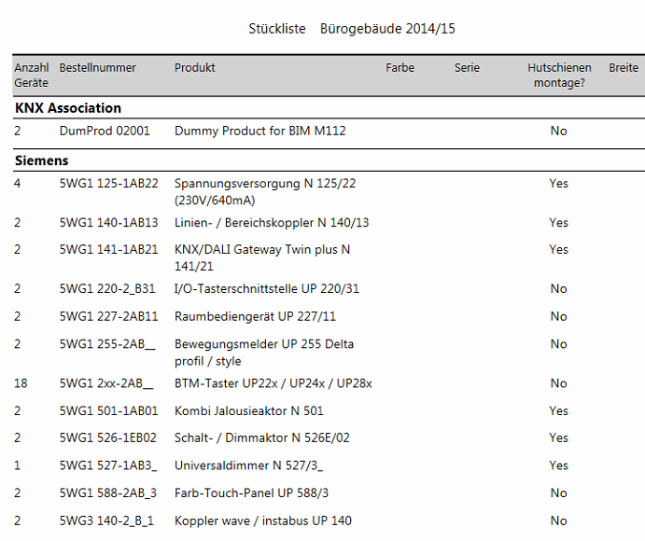
Figure 60: Group addresses (details) – Topology (Overview) – Parts list

Exporting group addresses
As already mentioned in chapter 7 group addresses can be exported in different text formats for processing outside ETS. To do so, click in the Group Address window with the right mouse button on the “Group Addresses” header and then on “Export Group Addresses”. Then select the desired format – e.g. CSV - and the most suitable delimiter (in case of XML of course this is not required).

These export files which serve – besides the PDF-formats – only as a “replacement for printed paper” can be very helpful later on, if it is necessary to reconstruct parts or even the whole project. Therefore you are able to assign meaningful names to the reconstructed group addresses.

Export OPC
Many KNX-systems are equipped with a SCADA-system (=visualisation). In such a case more and more OPC-servers are used, in order to present centrally data independent from the system below resp. to control functions.

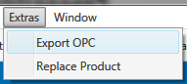
Figure 61: Data export
In most cases, current building management systems use more than one communication system. Apart from KNX, other field bus systems are used for different tasks. On the processing and management level, it should however be possible to link and present all data together. The operating and monitoring programs that are used here (SCADA software) do not have special “low-level” data exchange drivers in order to communicate directly with the relevant bus system, but use a so-called OPC server. (OPC Object Linking & Embedding for Process Control). The OPC standard defines the most important data types, which are identical in all systems. For instance, data types that can be presented in a 1 bit, 8 bit, 16 bit and 32 bit format. The OPC servers are driver programs, which on the one hand guarantee bus access via the available interfaces (for KNX: RS232, FT 1.2, IP or USB) and on the other hand, if possible, convert the data that is sent or received, in such a way that it can be clearly understood and interpreted on both sides These programs can be implemented either on standard PCs or in special hardware with direct bus access. In the case of hardware-based OPC servers, the data exchange nowadays is ensured via an IP network; in the case of software-based OPC servers, it is generally the same, but they can of course also run directly on the server PC, on which the SCADA software is installed

How can data from a KNX system get into the SCADA software?

Since ETS2 there is an export format for datapoints (better named as process points) in which not only the addresses and their names but also the assigned datapoint types are listed.
With the introduction of ETS5 the OPC export format has been transferred into the „normal“ group address export and is therefore only for compatibility reasons available as additional export function.
The OPC export contains all information which can be allocated to group addresses:
- Name of the main group
- Name of the middle group
- Group address (2 or 3 levels)
- Name of the subgroup
- Data type (EIS data type)
- Priority (this is important for sending telegrams via the OPC server)
- All other group addresses, which can be influenced directly or indirectly via device objects (e.g. all separate functional addresses in case of central addresses. This ensures that when operating a central command, the correct value will also be assigned to all separate functions).

This file is created in ASCII format – format with the extension “ESF” (=EIB Session File) and can thus not only be read from an OPC server (an additional program, which can be obtained from KNX members), but also from any other appropriate server program, which understands this format.

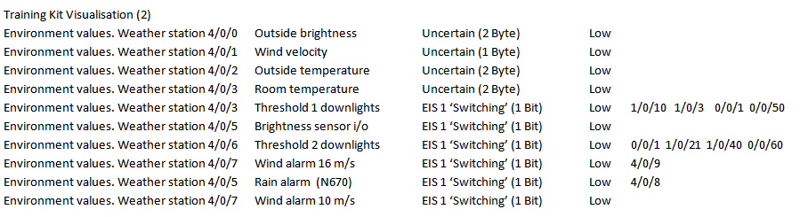
Figure 60: Export file contents

Data types
The already discussed data types (display format of the data) can be checked and also changed in ETS. You should clearly make the distinction between pure information (number of bits) and their interpretation (formatting, translation). In order not to create any non-practice-oriented restrictions, all group objects of KNX devices with the same data size can be linked to each other via group addresses. A functional unit, which for instance creates threshold value switching telegrams from the information of analogue value sensors, does not have a default data type for its associated objects. The relevant objects of most KNX devices do not have a data type set by default. If you manually change these settings, they will only affect the relevant object to which the change is made. What is this used for?
- When exporting data (group addresses), this additional information can be of importance later on;
- When recording data with the telegram recorder, the values are displayed correctly.
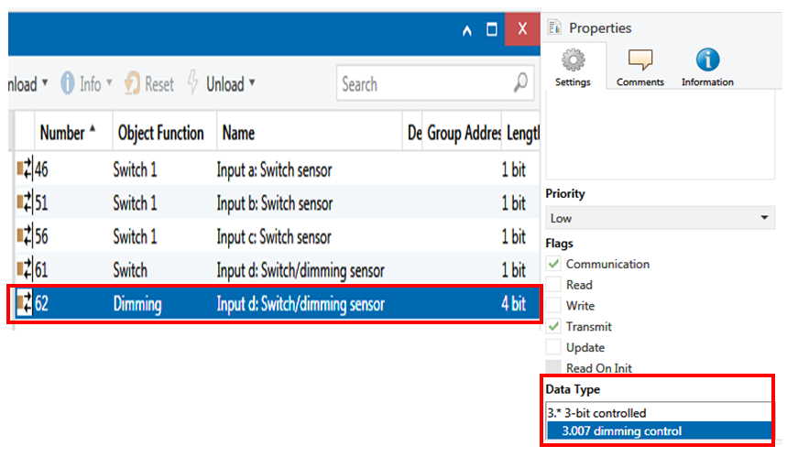
Figure 62: Object data types in the Properties dialog

Database handling, project backup, reconstruction

General
Managing data correctly is essential to any professional company nowadays. Also for KNX projects, possibilities exist to save them in such a way, that they are largely protected against data loss or damage, particularly while editing the project.

No database anymore!
Who used to work with former versions of ETS was always obliged to create a database into which the so-called ‘product data bases’ of the different manufacturers had to be imported. Only thereafter he was able to start the project design. The result was: The response time of these databases went down with the number of imported products. A further disadvantage was: For each newly created database the product import had to be carried out once again. This was time consuming and created often different versions with the consequence that the project interchanges could not be guaranteed.
Databases can become inconsistent every now and then, what leads to a tremendous effort for the reconstruction or even to data loss. With the introduction of ETS this database structure has been abolished. Now there is a management system, which allows storing and organizing the product data in a separate folder. These data can then be used in all projects. A bulky database does not have to be used anymore when working with a project

Backup and copies
Projects and product data should be saved (i.e. „exported“) at regular intervals. ETS5 does not provide any more special measures and automatisms, because now each project can be edited independent from other projects. Especially due to that reason the editing planners have to pay attention to secure („export“) regularly their projects. The exported projects are quasi the “backups” on which one can fall back later on.

In order to freeze a project status to some extent – e.g. if you intend to make major changes but still require a “fall-back position” – you just can create a 1:1 copy of a project, then rename it and continue to work.
Please pay attention: In the copy all programming flags will disappear!

Project reconstruction
If nevertheless project data should have been lost or destroyed, up to a certain extent a reconstruction may help to regain these data. A reconstruction via ETS requires product data for the reconstruction of the project.
The tool “Reconstruction” is an additional KNX-APP for which a fee is required. This tool generally works only with “standard ETS applications”. Applications which require plug-ins cannot be reconstructed with this tool. This can be done – if any – by manufacturer specific software.

Complete project documentation
Which documentation should be drawn up by the contractor? When can documentation be considered complete? What is the customer entitled to? And when?
These questions are regularly asked by many training participants. However, also in this case there is no standard answer as they are country specific to a large extent. You can however at least refer to the relevant regulations and ordinances, which define an approximate scope of the documentation to be provided. In the end, it is always the duty of the parties under contract to define at the initial planning and design stage and before the placing of the order, what constitutes a completely delivered “work”.
The following explanations refer to the regulation situation in Germany. The keyword “placement of order” leads to the most established basis of contractual terms at all, the VOB (Verdingungsordung für das Bauwesen: contract terms for the awarding of construction contracts).

Guidelines according to standards (VOB)
Part A of the VOB, § 9 “Work specifications” and § 10 “Submittal documents”, refers to the “documentation” according to §10 sect. 4 (1). In the VOB, Part B, reference is made in §1 “Type and scope of the activity” to the fact that it initially depends on the contract between the contractor and the client. If there are inconsistencies in the contract, all the available documentation – ranging from the technical specification as a basis for the specific and additional contract conditions to the technical contract conditions in accordance with the VOB, Part C – is then used for clarification purposes. This means in plain text that the work specification can already contain information directed at the later implementation of the documentation and in case of doubt can also be used to assert the rights of the client. An interesting factor in this context is represented by §3 no. 6 of the VOB, Part B: This deals with the rights of the client as regards the use of data processing programs, specifically required to display/or print the documentation. Open quote: “With regard to data processing programs, the client has the right to use software on the specified hardware with the specified properties in unmodified format. The client may make two copies for data security.” Close quote.
If this is related to KNX, only the ETS software can be meant as a “data processing program”. The “specified properties in unmodified format” are nothing other than the ETS project itself or the types of documentation that can be derived from it. It is more precisely detailed in the VOB, Part C – DIN 18382 “General contracting conditions for building works, low and medium voltage installations with nominal voltages up to 36 kV” (Reference: Issue December 2002).
Paragraph 3 “Implementation” contains the following:
Section 3.1.3 “The contractor must make all information available to the client necessary for the correct operation of the system.” And also: “This includes in particular:
- Wiring diagrams
- Address lists
- Parts lists
- .......
- Functional descriptions
Interpretation: A wiring diagram in a bus system in the broadest sense is the topology, which can be created both in the form of a table as well as in graphical format. Address lists are nothing other than the individual addresses and group addresses of our KNX devices. A parts list is self-explanatory. Functional descriptions are the brief notes in the device comments and address comments as well as - if there is insufficient space - the installation notes for each individual device
And finally:
Section 3.1.6 of DIN 18382: “The contractor must produce all …… necessary operating and maintenance instructions and necessary inventory plans as well as hand over this and individual project-specific data to the client”. It is thereby categorically stated that the customer has a legally recoverable right that this data and plans are handed over, including those that are more or less “hidden” in a KNX ETS folders. The contractor or the project designer of a KNX project should therefore be prepared to produce the underneath listed data and documents and issue them to the client in an appropriate and usable format:
- Contents of the project documentation
- Data directory: As the most simple way it appears to copy all project related ETS directories and folders on CD or an USB-stick and to hand it over to the client. This does not work anymore in an easy way with the current version of ETS and therefore will not be described any more by the KNX Association.
- Project export: In general, the completely exported project contains the additional files and DLLs of the plug-ins, nevertheless it should be checked, if this is really the case. (Re-import on a target computer, which does not contain any product data).
- The customer cannot however do anything with it without an appropriate ETS program. In other words, he must have an appropriate ETS license! Moreover, there may be a need for supplementary data, e.g. DLLs and help files or supplementary files of individual products, which may be indispensable if one wishes to change the products at a later date. Since ETS 3 and according to the manufacturers, all data from the “Baggage” directory can also be found in the relevant ETS database or nowadays in the ETS data directory. Yet for safety reasons these so-called “baggage” data can be copied. If ETS had been installed in the standard directory “C: \programs\ETS“ they can be found in the sub-directory “C: \programs\ETS\common files\EIBAsc\baggage” listed up according the manufacturer codes.

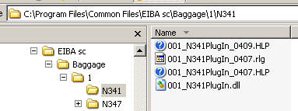
Figure 63: Baggage (=additional) Data
- Supplementary programs (SETUP): some KNX devices require additional setups (their own configuration programs). For completeness sake, such programs should also be put on the CD for the customer. These programs are normally supplied free of charge by the relevant manufacturers and can be copied without any restriction.
- Supplementary files (DLL, text etc.): see enumeration points 1 and 2!
- Parts lists
- Topology
- Building structure
- Group addresses
ETS offers an elegant way to archive all project data – including plans and data from other programs, tenders, functional specification etc. – in the project export file under “Project files”. If you click on “Add”, an Explorer window opens, where you can search for files and insert them.
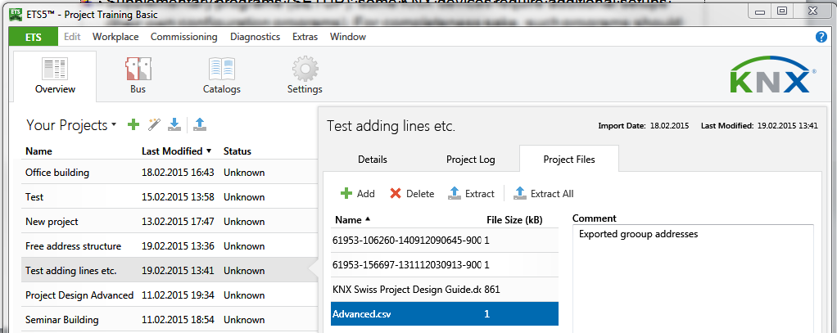
Figure 64: Inserting additional files

Note: All data that is handed over in electronic format requires specific program and operating system versions. This data is also part of the complete documentation.
The contractor of course does not need to issue licensed programs such as ETS or Windows.

Handover to the client
Finally, the documentation mentioned above must be handed over to the client in any case. What however is frequently discussed is how you can protect your rights as a contractor towards the client? 2 comments must be made:
According to paragraph 3.1.7 of the German contracting procedure for building works/DIN 18382, the examination of the building as regards operational reliability (evidence of each individual function) and according to the relevant DIN norms (or relevant international standards, for KNX e.g. EN 50090) must take place with appropriate documentation of the test results. The minutes of this examination must normally be handed out to the client before his acceptance for a possible re-check.
A technically skilled client could now make changes in the project later on, if he has the complete ETS project data.
In order to protect yourself as a contractor, it is advisable to activate the project password and to hand it over to the client separately in a sealed envelope. If any problems should occur after the handover, which should be remedied within the warranty conditions by the contractor, he could check to see whether the envelope is damaged or not. If the seal should have been removed, the contractor would not be liable for any malfunctions

Duties / behaviour of the contractor after handing over the project
The contractor must observe the legally stipulated warranty periods as common for the trade. What does that have to do with the “completeness of the documentation”?
Well, a contractor has to safeguard himself against unauthorised warranty claims by the client, once the installation has been completed. Many electronic data storage media are completely unsuitable for saving data over a longer period of time. Unfortunately this issue is often not considered sufficiently. The handling of critical data is often done too carelessly If there is a computer crash, e.g. because of a hard drive defect, or a virus has deleted all the files, big problems arise. One may too easily assume that the client might still have the data, because it has already been handed over and could therefore be easily recovered.
But what happens, if the client has in the meantime also lost data? Or the client has initiated a lawsuit because there are differences of opinion regarding warranty issues etc.? Without your own evidence, you are in trouble if you are the accused.
Therefore – in his own interest – the contractor should save all data on special media for long life storage, and moreover store it in a safe place, e.g. in a locked vault at a bank. In large projects, where small mistakes can still cause a significant loss of money, it is recommended – even, if it costs money – to have the data legally certified, sealed and then deposited at a bank. In case of warranty issues, the validity of this data can then not be put into question

